|  |  |  |  |
| --- | --- | --- | --- |
| \\lyng-dc1\StaffShared\Learning Bugs Animals ALL subjects\characters bugs animals\Cyril the Snail - History.jpeg**Lyng Primary School Knowledge Organiser** | | | |
| **History Topic:** | **The Maya Civilisation -** How did the Maya civilisation compare to the Anglo-Saxons? | Year 6  *Civilisation, Communication and Inventions* | Autumn 2 |

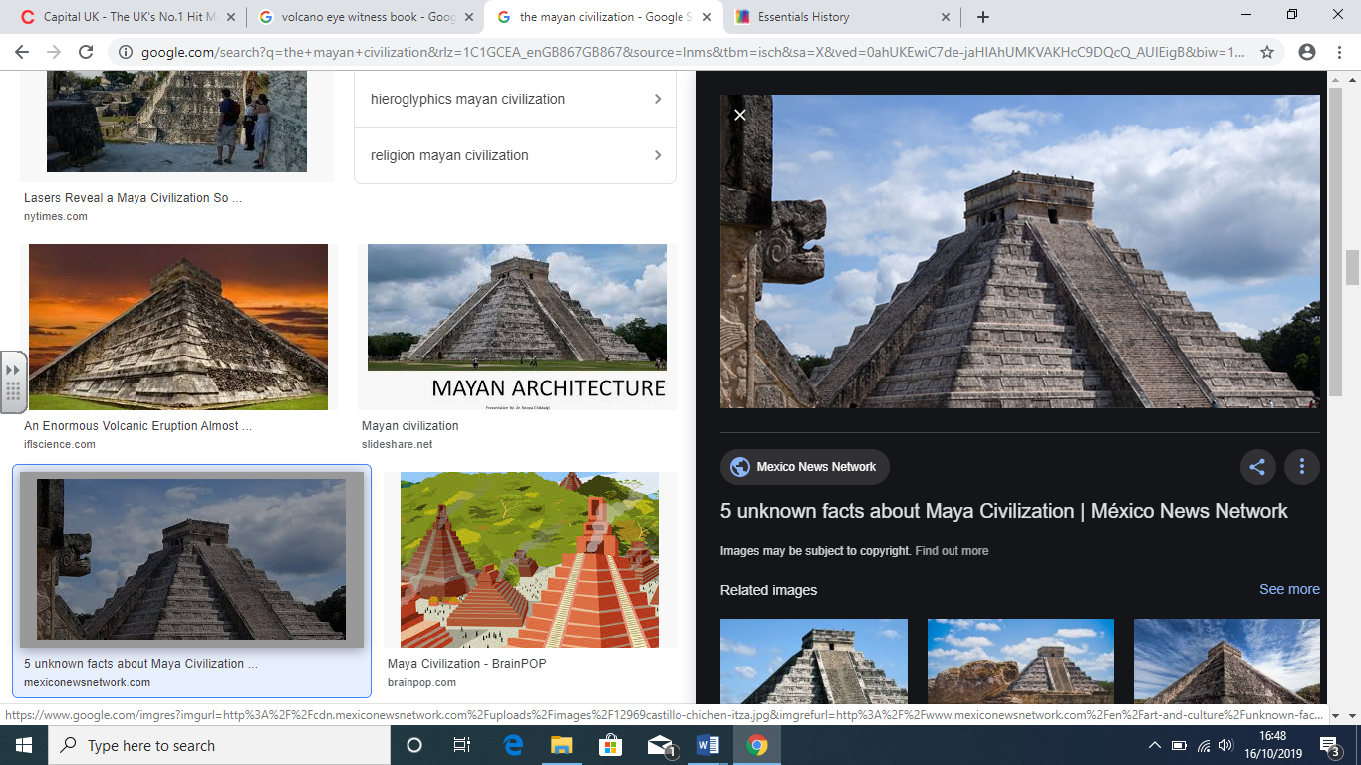

|  |  |
| --- | --- |
| **What Step On and Goldilocks words will I use?** | |
| **Spelling** | **Definition** |
| agriculture | Farming – growing crops and rearing animals. |
| astronomy | The study of space, planets, stars and the universe. |
| calendar | A system used to divide up and organise events in time. |
| civilisation | The society, culture and a way of life of a particular area. |
| city – state | A large, independent city running the surrounding area. |
| codices | Ancient handwritten texts. Maya codices could be unfolded like a concertina. One text is called a codex. |
| crops | A plant that is grown on a large scale – usually wheat, fruit or vegetables. |
| drought | A prolonged period of no rain, leading to water shortages. |
| hieroglyphics | Writing which is made up of pictorial symbols. |
| sacrifice | An act of slaughtering an animal or a person as an offering to a God or Gods. |
| settlement | A place where people establish a community. |
| slash and burn | Cutting and burning down trees and plants to clear land. |
| temple | A building devoted to the worship of of a God or Gods. |
| worship | To show love and devotion – usually to a God or Gods. |

**Background information for teachers and parents.**

Mayan society was based in what is known as Mesoamerica (Central America). The Maya civilisation was organised into city states; each city state was ruled by a different noble family. The Maya lived in settlements with a central temple/pyramid as a focal point. They existed from 2000BC to approximately 1697AD. They were considered an advanced civilisation due to their many achievements.

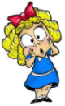

**Hook**

Let’s say we live near the volcano…

Children make a volcano.

|  |  |
| --- | --- |
| **When? (Timeline of key events)** | |
| 2500 BC– 910 AD | Start and end of the Ancient Mayan civilisation |
| 250 AD | Start of classical period of Mayan civilisation |
| 900 AD | Anglo-Saxons control England |
| 1519-1521 AD | Spanish invaders (conquistadors) arrive in Mesoamerica |
| 1813 | American explorer and writer, John Lloyd Stephens, and British artist, Frederick Catherwood, explore Copán reigniting interest in the Maya civilisation. |
| 21st December 2012 | The Mayans predicted the end of the world would happen on this date - fortunately, they were wrong! |

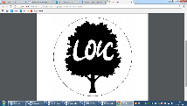

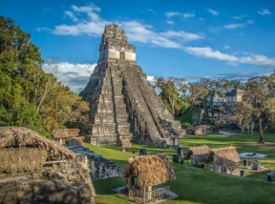

**TRIP/VISITOR**

Cadbury World to complete a Maya workshop!



**Did you know?**

The Mayan idea of beauty included a flattened forehead, cross eyes, tattoos, teeth filing and large noses!

**Our Storytelling Approach to enhance engagement**

|  |  |  |
| --- | --- | --- |
| **People:** Citizens of Colima  (Jorge Mendez – he was there at the last eruption and survived. He thinks that nothing will happen to him even though volcanologists suspect the eruption will be the most destructive yet). | **Place:** Colima, Mexico | **Problem:** The volcano is about to erupt and the citizens need to evacuate the area. Where are they going to go? How are they going to get there? |

**Key Historical Facts**

**Focus Text**

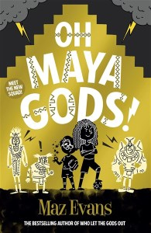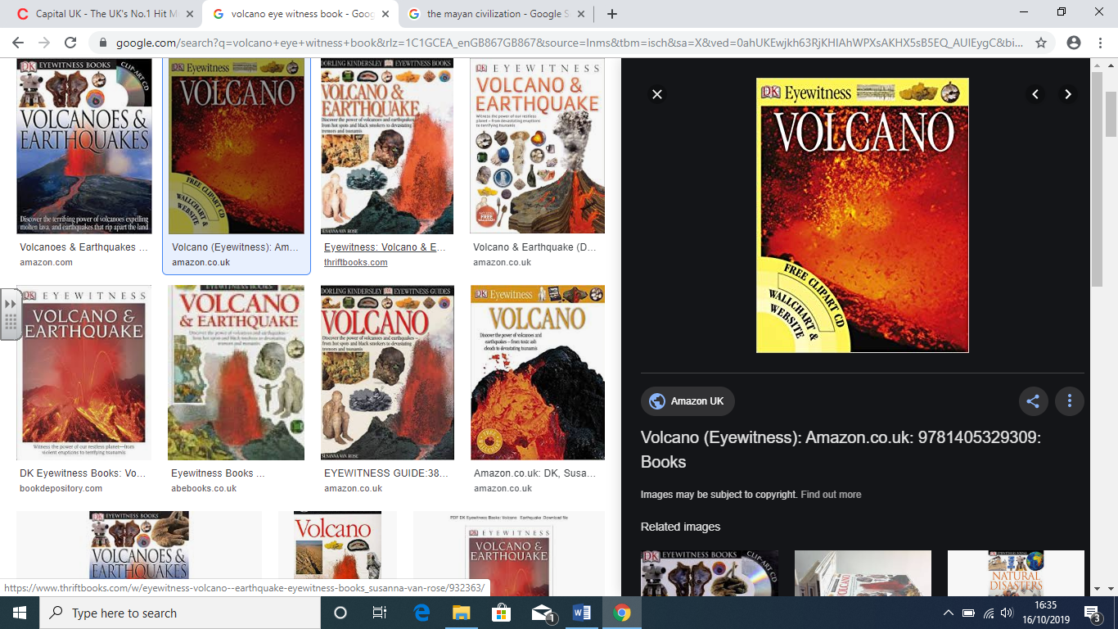

|  |  |
| --- | --- |
| **Maya Writing System**  The Maya writing system was used to write several different Maya languages. It was made up of many symbols called glyphs. Logograms are glyphs representing whole words. Syllabograms are glyphs representing units of sound (syllables). The glyphs were carved on stone buildings and monuments and painted on pottery. Maya scribes also wrote books called codices. |  |
| **Life in the rainforest**  The Maya faced many challenges settling in the rainforest including dangerous animals, dense vegetation and shady conditions, which made growing crops difficult. They solved these problems by slashing and burning trees to clear rainforest areas, becoming adept hunters and developing crops that could grow successfully in the conditions, such as cocoa and maize. |  |
| **Comparison to Anglo-Saxons**  Anglo Saxons settled in Britain from around 400 AD to 1066 AD. The Maya civilization was at its peak in Mesoamerica from 250 AD to 900 AD. Interestingly, although these civilizations occurred at a similar period of time, their lives were very different. | https://tse3.mm.bing.net/th?id=OIP.XiDyRK05OLIG6DibY1qzAwHaHV&pid=Api&P=0&h=180 |

We will be reading a variety of non-fiction texts based on volcanoes. We shall also be exploring a new class novel – Oh Maya Gods’ by Maz Evans

* **Who** were the **Maya** and **where** did they **live?**
* **How** did the **Maya settle** in the **rainforest?**
* **How** did the Maya civilisation **compare** to the Anglo-Saxons?
* **How** did the **Maya writing system** work?
* **Why** did the **Spanish attack?**
* **What** can **archaeological remains** tell us about the Maya?
* **The decline of the Maya cities: man-made or natural disaster?**

**Enquiry questions that we shall investigate during the topic:**

**Agreed Outcome**

A persuasive letter to Jorge Mendes convincing him to evacuate.

|  |  |  |  |
| --- | --- | --- | --- |
| \\lyng-dc1\StaffShared\Learning Bugs Animals ALL subjects\characters bugs animals\Cyril the Snail - History.jpeg**Lyng Primary School Knowledge Quiz** | | | |
| **History Topic:** | **The Maya Civilisation -** How did the Maya civilisation compare to the Anglo-Saxons? | Year 6  *Civilisation, Communication and Inventions* | Autumn 2 |

|  |  |  |
| --- | --- | --- |
| 1. What was the purpose of Maya masks? | **S** | **E** |
| 1. Worn in battle |  |  |
| 1. Decoration in the house |  |  |
| 1. Worn at death |  |  |

|  |  |  |
| --- | --- | --- |
| 6. The Mayan people were successful at farming because | **S** | **E** |
| 1. They were strong. |  |  |
| 1. Studied the stars and weather |  |  |
| 1. Had been taught by their ancestors |  |  |

**Our Mayan**

**Quick Quiz**

|  |
| --- |
| 1. What was a challenge faced by the Maya in the rainforest? |
| S = |
| E = |

|  |  |  |
| --- | --- | --- |
| 7. What did the Maya invented something that was more detailed than ours today? | **S** | **E** |
| 1. Number system |  |  |
| 1. Writing system |  |  |
| 1. A calendar |  |  |

|  |
| --- |
| 8. Describe a similarity with the Maya and the Anglo-Saxons. |
| S =  E = |

|  |  |  |
| --- | --- | --- |
| 9. What’s a drought? | **S** | **E** |
| 1. Not enough rainfall, leading to a lack of water. |  |  |
| 1. Not enough food,. |  |  |
| 1. Not enough weapons, leading to war. |  |  |

|  |
| --- |
| 10. Describe a difference between the Anglo-Saxons and the Maya. |
| S =  E = |

|  |  |  |
| --- | --- | --- |
| 1. Mayans added chilli to cocoa powder to enjoy as a drink | **S** | **E** |
| True or False |  |  |

|  |  |  |
| --- | --- | --- |
| 1. The number and writing system that the Maya developed was similar to… | **S** | **E** |
| The Vikings |  |  |
| The Egyptians |  |  |
| The Saxons |  |  |

**Start –**

**End -**

|  |  |  |
| --- | --- | --- |
| 1. Who conquered the Maya, ending their rule? | **S** | **E** |
| The Spanish |  |  |
| The British |  |  |
| The Vikings |  |  |